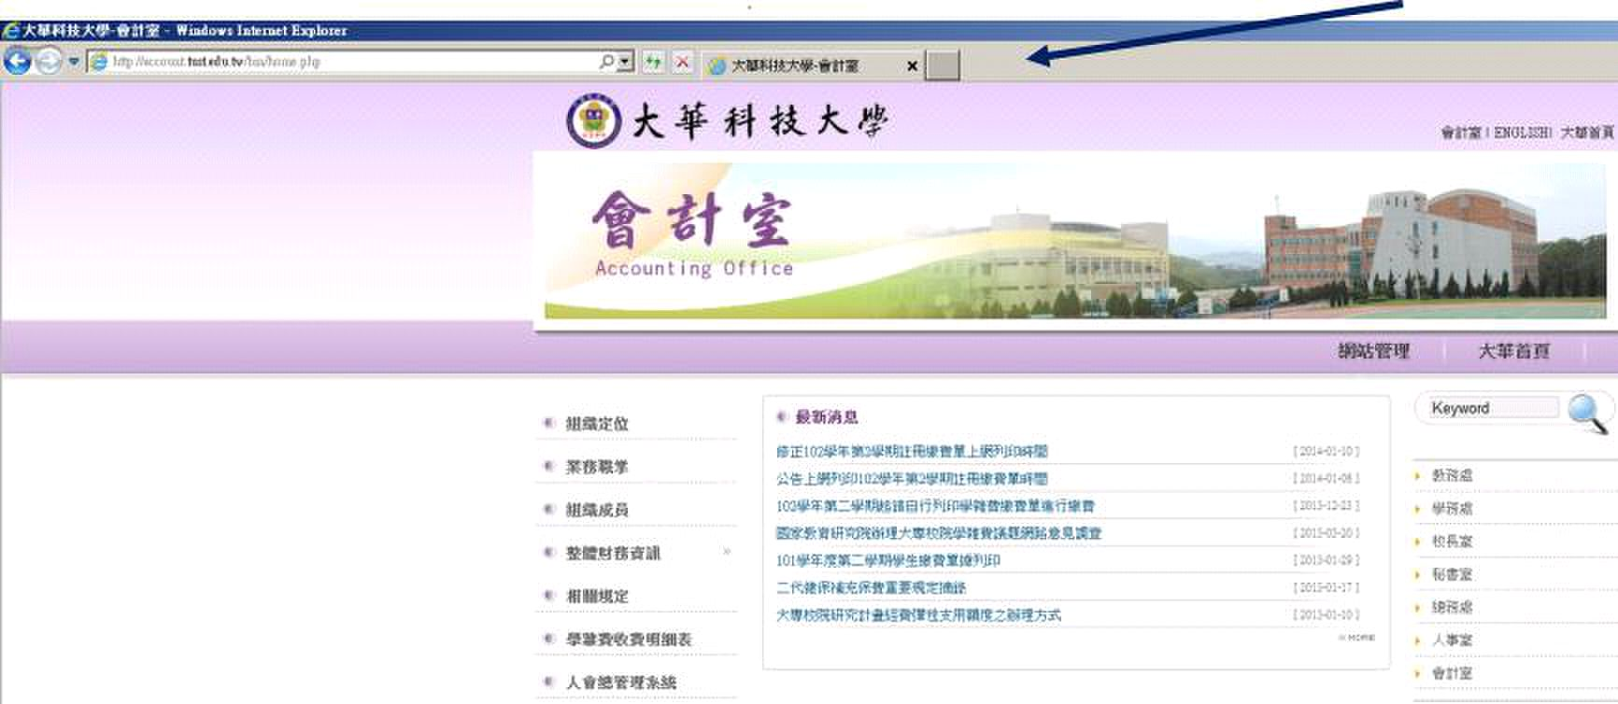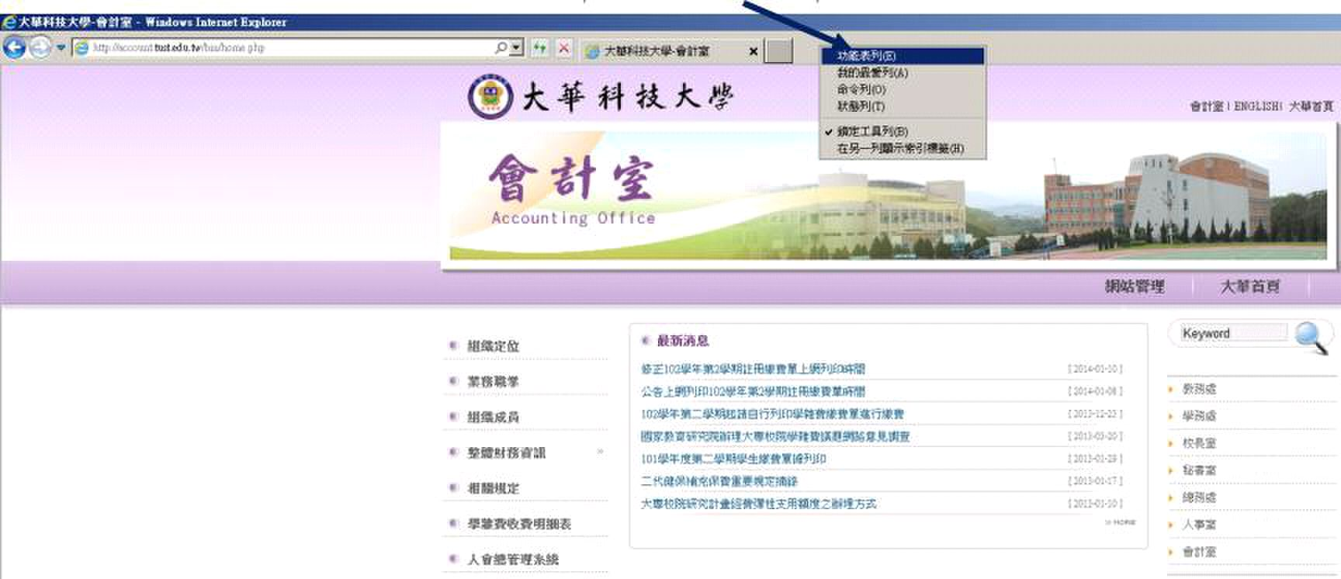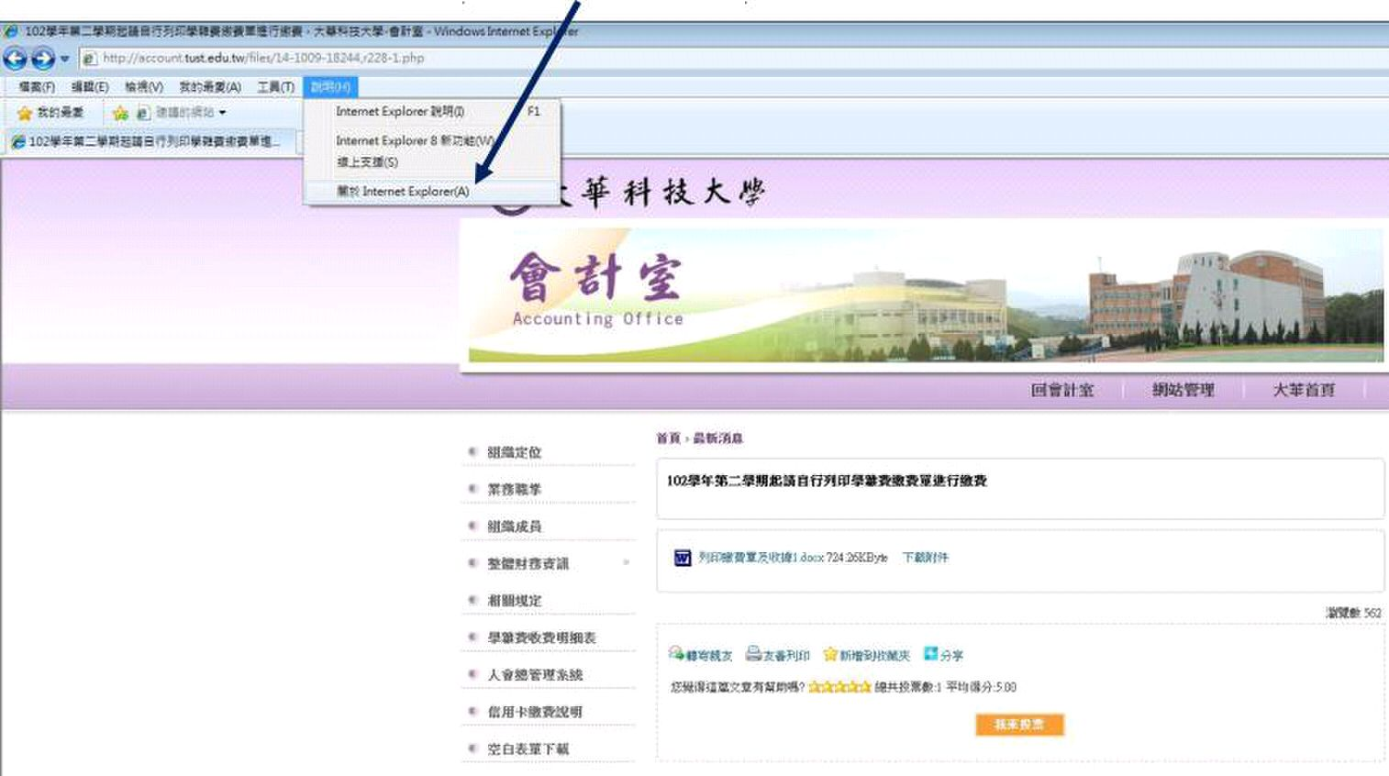

|  |  |
| --- | --- |
| 1.檢查 Internet Explorer |  |

|  |  |
| --- | --- |
| 2. |  |

|  |  |  |
| --- | --- | --- |
| 3. | 將功能表列勾選，點選功能表中的說明 | 查 Internet Explorer 之版本 |

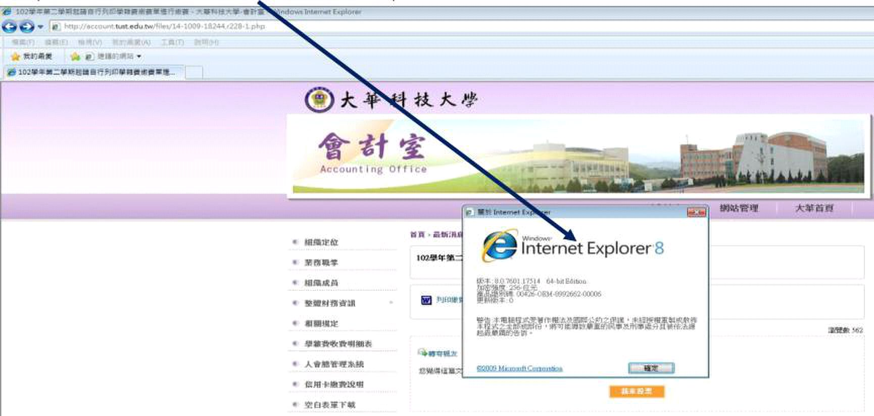

4. 檢查 Internet Explorer

|  |
| --- |
| 之版本 |